Google App Store Clusters

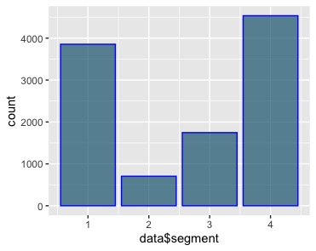

Here are the results of some clustering I did in R on a Google App store dataset that records data on the most popular apps in the Google Play Store. I divided the dataset into 4 clusters and grouped apps that were most similar in terms of ratings, reviews, and number of installs. The key insight here is that app success as measured by number of installs depends on review number and review quality; though, as the Hexbin chart, there are a few apps that are extremely successful with very few reviews. #datascience #datavisualization #R #clustering #data #analysis #visualization #segmentation